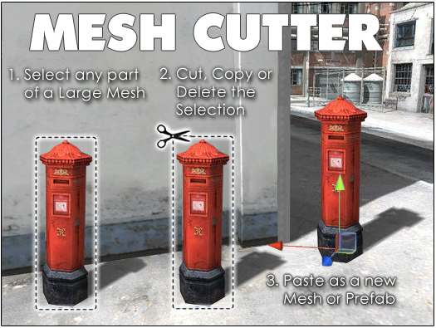
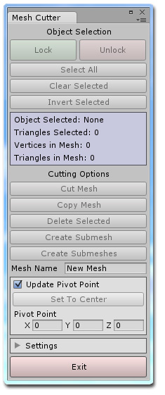
Starting Mesh Cutter

Thank you for your purchase of Mesh Cutter. After downloading and importing the package you will notice a new folder called Mesh Cutter has been added to the project window. To open the program, click on the Window menu item in Unity, hover the mouse over the Mesh Cutter item and then click on Open Window. The Mesh Cutter window is tabbed so you can dock the window by clicking on its tab and dragging it next to the other windows.

About Mesh Cutter

Often you will find that you have a large mesh made up of many small parts. Some of the parts you may want to keep but often there are parts you would like to move or remove altogether. With Mesh Cutter you can now quickly select different parts of the mesh and cut, copy or remove them. The program will preserve the materials and submeshes of the large mesh and create a new mesh and prefab whenever you cut or copy a part, transferring the materials and submeshes to the new object. You can also re-center and adjust the pivot point of the new object to use it elsewhere in your projects.
Getting Started

When the program opens you will notice that most of the buttons are grayed out. To begin you first need to select an object that has a Mesh Filter attached. Sometimes you will need to click on a mesh twice to get to the child mesh of that object. In the image below the parent object is selected and all of the mesh wireframe is visible.

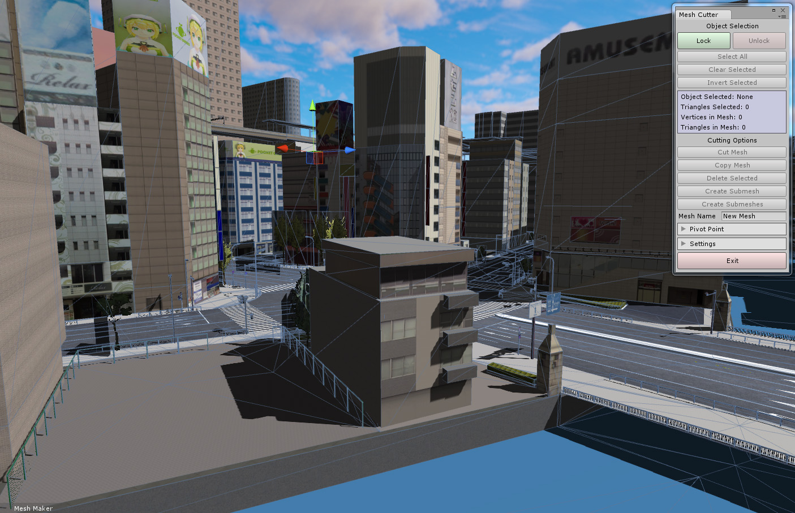

By clicking on an object again you will notice that the child object is now selected as it is the only object showing a wireframe as shown in the next image.

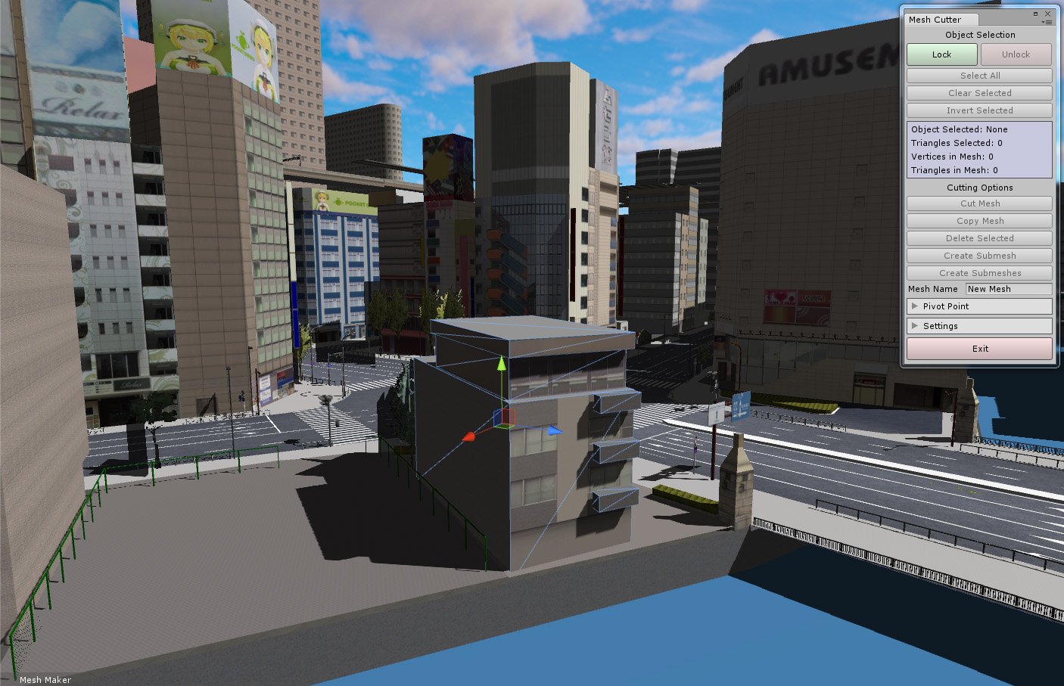

The wireframe is also slightly brighter indicating that this object has a Mesh Filter attached. Once this object is selected you will also notice that the Lock button at the top of the Mesh Cutter window is no longer grayed out. You can now click on this button to lock the object within the editor so that you can begin editing it. When an object is locked you will not be able to select another object in the scene until you click on the Unlock button in Mesh Cutter. This prevents other objects from being accidentally selected while working and tells the program that you are ready to start selecting some of the triangles of this mesh.

Selecting and Deselecting Triangles

To select the triangles you simply left click on them or you can hold the left mouse button down and drag the mouse pointer over the surface of the mesh to select multiple triangles quickly. To deselect a triangle first hold down the Shift key before left clicking on the triangles. Sometimes it may be quicker to select all of the triangles of the mesh and then deselect the triangles you don't want by using the Shift key. You can do this by clicking on the Select All button from Mesh Cutter. Once you have selected some triangles you can also clear the selection or invert the selection using the buttons on the Mesh Cutter window. Below is an image of a building with some of the triangles selected. If you want to change the highlight color you can do this in the settings which are covered later in this tutorial.

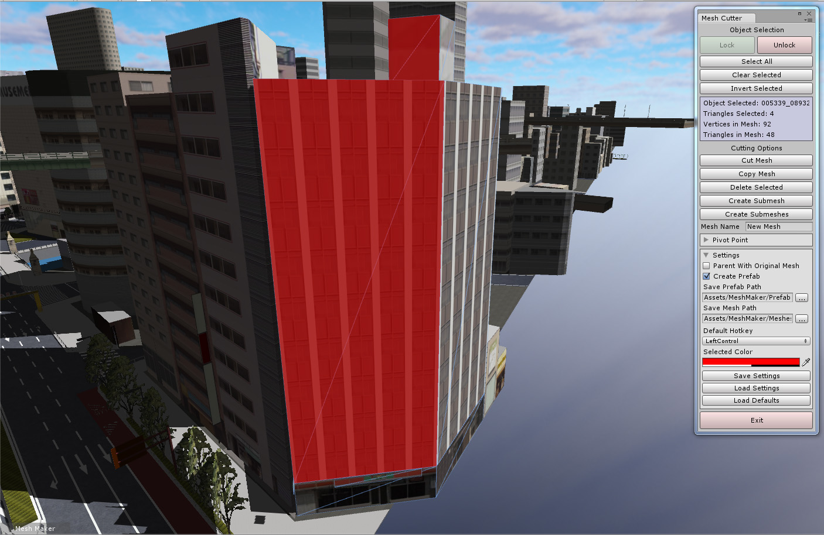

Selecting and Deselecting Using the Marquee

If you need to select a large part of a mesh then the quickest way is to drag a selection box around them. In the image below part of a bridge has been highlighted using the marquee tool. By default the hotkey used to begin dragging a selection box is the left Ctrl key. Sometimes you will need to left click in the scene first to make sure the scene view window is active before you begin your selection. To quickly deselect using the marquee tool you need to hold down both the hotkey and the shift key at the same time before dragging a box around the selected triangles. You can also change the default hotkey in the settings if you prefer.

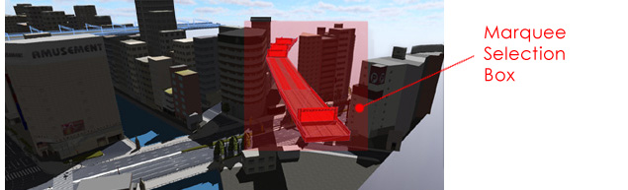

Cutting Options

Once you have selected the triangles you want there are five different options for operating on the mesh. If an option creates a new mesh and prefab these are saved in the Meshes and Prefabs folders within the program folder by default. These can be changed to different folders within the settings area.

1. Cut Mesh
This option will cut the selected part of the mesh and create a new mesh and prefab. The new mesh will be added to the hierarchy and the scene at the same position from which it was cut. It will remain in the scene even if an undo is performed unless Parent With Original Mesh is selected in the settings. If Parent With Original Mesh is selected then it will be added to the hierarchy as a child object of the original mesh and deleted when an undo is performed.

2. Copy Mesh
This option will copy the selected part of the mesh. It creates a new mesh and prefab but does not alter the original mesh. The new mesh will be added to the hierarchy and the scene at the same position from which it was copied. It will remain in the scene even if an undo is performed unless Parent With Original Mesh is selected in the settings. If Parent With Original Mesh is selected then it will be added to the hierarchy as a child object of the original mesh and deleted when an undo is performed.

3. Delete Selected
This option just deletes the selected parts without creating a new mesh or prefab.

4. Create Submesh
This option will take all of the selected triangles and group them together before adding a new submesh to the original mesh. This allows you to then apply a new texture to the new submesh triangles.

5. Create Submeshes
Much like the option above, this option will take all of the selected triangles and create one or more submeshes depending on whether they were originally a part of a submesh. Normally each submesh will have a different texture but if a mesh is using a texture atlas (groups of smaller textures combined into one texture) then this is not always the case.

Undo and Redo Operations

You can undo and redo any cutting actions by using the Ctrl-Z and Ctrl-Y shortcuts. Please be aware that when performing an undo or redo that the selected triangles will be deselected automatically to prevent problems when changing between objects.

Mesh Name
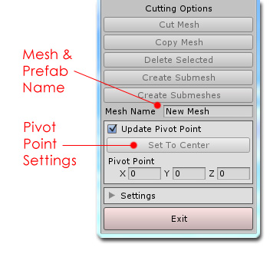
When performing a cut or copy operation the new mesh and prefab will be given the name entered here. The program will alert you if the mesh or prefab name already exists before the operation is performed.

Pivot Point

When cutting or copying part of a mesh you may want to move the pivot point so that the new mesh and prefab will be centered.

By default the Update Pivot Point feature is set to active but has no effect since the fields are set to zero by default.
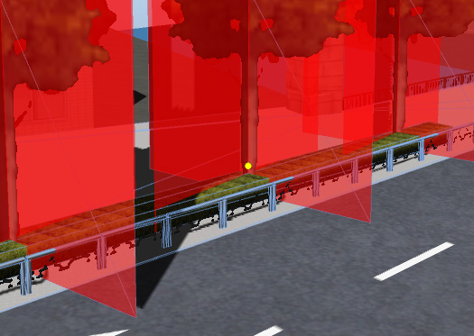
If this feature is active and there is at least one selected triangle then you will see a small yellow sphere in the scene view where the pivot point will be located when the new mesh is created. To quickly set the pivot point to the center of all of the selected triangles you can click on the Set To Center button. To adjust the final position you can change the fields below this button. A quick way to adjust these values is to click on the field labels and drag the mouse left or right.

The final position of the new mesh which is added to the scene after a cut or copy operation has been tested with meshes that have all sorts of transforms including negative scale values and when parented to other game objects with negative scale values, etc. In all of the tests there hasn't been a problem but there may be some edge cases that haven't been discovered yet.

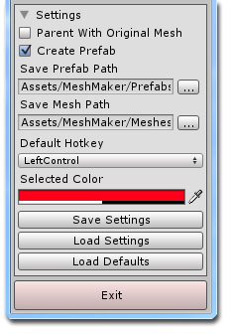
Settings

To access the settings menu click on the small arrow next to the Settings label and the box will expand.

The first option allows you to parent the new mesh with the selected object. It will appear in the hierarchy as a child of the original object. When an undo is performed it will be removed completely from the hierarchy but remain as a new file in the Meshes folder by default.

The prefab is created automatically whenever a cut or copy operation is performed. To disable this feature simply un-check the box labeled Create Prefab.

You can change the default paths to where new meshes and prefabs will be saved by clicking on the buttons to the left of the Path fields and selecting a new folder within the project assets folder.

You can change the default hotkey used by the program by selecting a new key to use from the drop down menu at the bottom of the settings.

You can also change the default color for the selected triangles and selection box here as well.

To make a backup or restore your preferred settings you can click on the Save Settings and Load Settings buttons. If you need to you can also restore the original settings by clicking on the Load Defaults button.

Notes

If you are working on a mesh with negative scale values and you have selected Parent With Original Mesh then you will run into an issue where the child object will act like it is snapping to the grid. This is standard behavior in Unity and it is discussed here and here.

If you are cutting or copying a part of a mesh that is flat and single sided the prefab may appear as just a gray icon in the inspector. This sometimes happens when the prefab is facing in the opposite direction but you can rotate the preview icon in the inspector by left clicking on its icon and dragging the mouse around to see it. There doesn't appear to be a solution for this as I have no control over the orientation of the prefab in the inspector.

The city model used in the screenshots and videos is called Japanese Otaku City and was created by ZENRIN CO. LTD. I would like to thank the creators of this asset which is available for free on the asset store at https://www.assetstore.unity3d.com/en/#!/content/20359

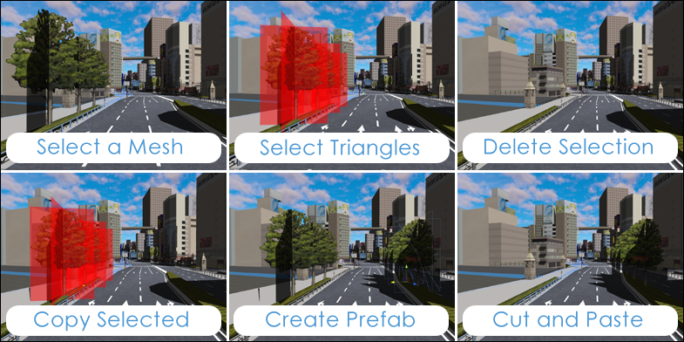

In Unity 5 it is recommended to turn of continuous baking of lightmaps by going to the menu and navigating to Window/Lighting/Lightmaps and unchecking the checkbox. This will prevent lag and stuttering in the editor.

I hope you find many uses for Mesh Cutter and if you have a problem or a suggestion please contact me at support@meshmaker.com

To learn more about Mesh Cutter and to view the tutorial videos you can visit
MeshMaker.com

